New Practice Member Application
Name___________________________________ Date of Birth____ /____ /____ Age_____ Male/Female

Address____________________________________City______________________State______ Zip_______
Phone: Cell_____________________Home___________________Cellular Provider___________________
Email Address__________________________________ Occupation________________________________
Employer’s Name______________________________________ Single / Married / Divorced / Widowed
Spouse’s Name______________________________________ Number of Children___________________
Names, Ages, & Gender___________________________________________________________________
Who may we thank for referring you?________________________________________________________

List The Health Concerns That Brought You Into This Office
Health Concern: Rate of Severity When did Have you had the Did the Are symptoms
List according 0 = no pain this problem problem before? problem begin constant (C) or
to severity.⬇ 10 = unbearable start? If so, when? with an injury? intermittent (I)?

Primary:_______________ ______________ ______________ ______________ ______________ ______________
Second:_______________ ______________ ______________ ______________ ______________ ______________
Third: _______________ ______________ ______________ ______________ ______________ ______________
Fourth: _______________ ______________ ______________ ______________ ______________ ______________
Have you ever seen other doctors for these conditions? □ Yes □ No
If Yes: □ Chiropractor □ Medical doctor □ Other____________________________________________
Who?_____________________________ When?_____________________________ Results?_____________________________
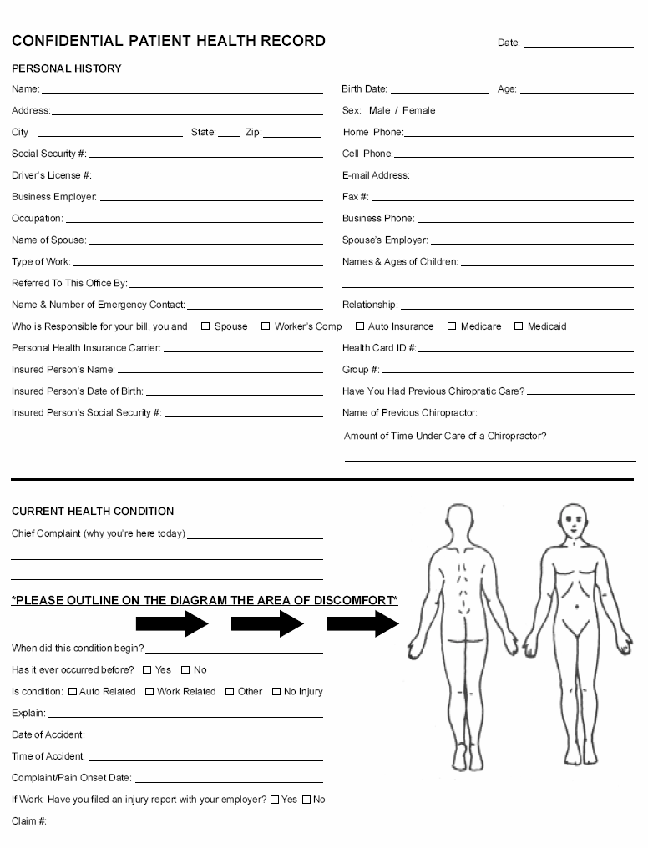
PLEASE MARK the areas on the Diagram with the following letters to describe your symptoms:
R = Radiating B = Burning D = Dull A = Aching N = Numbness S = Sharp/Stabbing T = Tingling
What relieves your symptoms? _________________________________________
What makes your symptoms feel worse? _________________________________
What are your Health Goals? 1)______________________________________________________________
2) ______________________________________________ 3) ________________________________________________
Please Mark “P” For In The Past OR Mark “C” For Currently Have:
___ Headaches ___ Ear Infections ___ Sinus Issues ___ Kidney Problems ___ Sexual Dysfunction
___ Migraines ___ Hearing Loss ___ Frequent Colds ___ Bladder Problems ___ Sleep Problems
___ Jaw/TMJ Pain ___ Ringing in the Ears ___ Thyroid Issues ___ Menstrual Problems ___ Tight/Sore Muscles
___ Neck Pain ___ Dizziness ___ Asthma ___ Prostate Problems ___ Sports Injury
___ Shoulder Pain ___ Loss of Energy ___ Chest Pain ___ Infertility ___ Sciatica
___ Arm Pain ___ Nervousness ___ Heart Problems ___ Fibromyalgia ___ Arthritis/Joint Pain
___ Upper Back Pain ___ Double/Blurry Vision ___ Nausea ___ Epilepsy/Convulsions ___ GERD/Gastric Reflux
___ Mid Back Pain ___ Anxiety ___ Ulcers ___ Tremors ___ Numb/Tingling in Arms/Hands
___ Lower Back Pain ___ ADD/ADHD ___ Digestive Issues ___ Disc Problems ___ Numb/Tingling in Legs/Feet
___ Hip/Leg Pain ___ Loss of Balance ___ Diarrhea ___ Scoliosis ___ Stomach Problems
___ Knee Pain ___ Depression ___ Constipation ___ Poor Posture ___ High/Low Blood Pressure
___ Foot Pain ___ Allergies ___ Bed Wetting ___ Skin Problems ___ Difficulty Breathing
Other:___________________________________________________________________________________________________________________

Please Mark “P” For In The Past OR Mark “C” For Currently Have:
___Stroke ___Cancer ___Heart Attack ___Spinal Surgery ___Spinal Bone Fracture
___Scoliosis ___Diabetes ___Arthritis ___Seizures ___Other Conditions/Diseases
List all surgical operations & years: __________________________________________________________
List any other injuries to your spine, minor or major, that the doctor should know about: __________________________________________________________________________________________
List all over the counter & prescription medications you are on, & the reason for each: __________________________________________________________________________________________
Have you ever been in an auto accident? List all:______________________________________________
Have you ever been knocked unconscious? □ Yes □ No Fractured A Bone? □ Yes □ No
If yes to either of the above, please describe:_________________________________________________
Other trauma:_____________________________________________________________________________
Social History
1. Smoking: How often? □ Daily □ Weekends □ Occasionally □ Never
2. Alcohol: How often? □ Daily □ Weekends □ Occasionally □ Never
3. Exercise: How often? □ Daily □ Weekends □ Occasionally □ Never
4. Have you consumed any caffeine or products with caffeine in the past 48 hours? □ Yes □ No

Quadruple Visual Analogue Scale
Please circle the number that best describes the question asked. If you have more than one complaint, please answer each question for each individual complaint and indicate the score of each complaint.
Back Pain
Headaches
EXAMPLE: No pain Worst possible pain
0 1 2 3 4 5 6 7 8 9 10
- How would you rate your pain RIGHT NOW?

0 1 2 3 4 5 6 7 8 9 10

2. What is your typical or AVERAGE pain?

0 1 2 3 4 5 6 7 8 9 10

3. What is your pain level at its BEST? (How close to 0 does your pain get at its best?)

0 1 2 3 4 5 6 7 8 9 10
What percentage of you’re awake hours is your pain at its best? ______%

4. What is your pain level at its WORST? (How close to 10 does your pain get at its worst?)

0 1 2 3 4 5 6 7 8 9 10

What percentage of your awake hours is your pain at its worst? ______%

Name: Date:

Activities Of Life
Please identify how your current condition is affecting your ability to carry out activities that are routinely part of your life:
ACTIVITY: EFFECT:
Carrying Groceries No Effect Painful (can do) Painful (limits) Unable to Perform
Sit to Stand No Effect Painful (can do) Painful (limits) Unable to Perform
Climbing Stairs No Effect Painful (can do) Painful (limits) Unable to Perform
Pet Care No Effect Painful (can do) Painful (limits) Unable to Perform
Driving No Effect Painful (can do) Painful (limits) Unable to Perform
Extended Computer Use No Effect Painful (can do) Painful (limits) Unable to Perform
Household Chores No Effect Painful (can do) Painful (limits) Unable to Perform
Lifting Children No Effect Painful (can do) Painful (limits) Unable to Perform
Dressing No Effect Painful (can do) Painful (limits) Unable to Perform
Shaving No Effect Painful (can do) Painful (limits) Unable to Perform
Sexual Activities No Effect Painful (can do) Painful (limits) Unable to Perform
Sleep No Effect Painful (can do) Painful (limits) Unable to Perform
Static Sitting No Effect Painful (can do) Painful (limits) Unable to Perform
Static Standing No Effect Painful (can do) Painful (limits) Unable to Perform
Walking No Effect Painful (can do) Painful (limits) Unable to Perform
Washing/Bathing No Effect Painful (can do) Painful (limits) Unable to Perform
Sweeping/Vacuuming No Effect Painful (can do) Painful (limits) Unable to Perform
Dishes No Effect Painful (can do) Painful (limits) Unable to Perform
Laundry No Effect Painful (can do) Painful (limits) Unable to Perform
Yard work No Effect Painful (can do) Painful (limits) Unable to Perform
Garbage No Effect Painful (can do) Painful (limits) Unable to Perform
Concentration (Reading) No Effect Painful (can do) Painful (limits) Unable to Perform
Other: ___________ No Effect Painful (can do) Painful (limits) Unable to Perform
Other: ___________ No Effect Painful (can do) Painful (limits) Unable to Perform

Family Health History

This form is to assist the doctors by providing past health history information for their review.
CONDITION | SPOUSE | SON | DAUGHTER | MOTHER | FATHER
Headaches
Neck Pain
Jaw/TMJ Pain
Shoulder Pain
Back Pain
Hip/Leg Pain
Arthritis/Joint Pain
Ear Infections
Hearing Loss
Dizziness
Loss Of Energy
Nervousness
Blurred/Double Vision
Anxiety
ADD/ADHD
Depression
Allergies
Sinus Issues
Thyroid Problems
Asthma
Breathing Problems
Heart Problems
High/Low Blood Pressure
Stomach Problems
Bed Wetting
Infertility
Sciatica
Fibromyalgia
Poor Posture
Sleep Problems
Stroke
Cancer
Heart Disease
Diabetes
Arthritis
Alzheimer’s

Informed Consent For Chiropractic Care

Chiropractic care, like all forms of health care while offering considerable benefits may also provide some level of risk. This level of risk is most often very minimal, yet in rare cases, injury has been associated with chiropractic care. The types of complications that have been reported secondary to chiropractic care include: sprain/strain injuries, irritation of a disc condition, and rarely, fractures. One of the rarest complications associated with chiropractic care occurring at a rate between one instance per one million to one per two million cervical spine (neck) adjustments may be a vertebral injury that could lead to a stroke.

Prior to receiving chiropractic care in the chiropractic office, a health history and physical examination will be completed. These procedures are performed to assess your specific conditions, your overall health and in particular your spinal health. These procedures will assist us in determining if chiropractic care is needed, or if any further examinations or studies are needed. In addition, they will help us determine if there is any reason to modify your care or provide you with a referral to another health care provider. All relevant finding will be reported to you along with a care plan prior to beginning care.
- I understand and accept that there are risks associated with chiropractic care and give consent to the examination that the doctor deems necessary and the chiropractic care, including spinal adjustments, as reported following my assessment.

- I authorize and request payment of insurance benefits directly to Dr. Erick Dobrzynski, D.C. I agree that this authorization will cover all services rendered until I revoke the authorization. I agree that a photocopy of this form may be used in place of the original. All professional services rendered are charged to the practice member. It is customary to pay for services when rendered unless other arrangements have been made in advance. I understand that I am financially responsible for charges not covered by this assignment.

Print Name: ______________________________________________________

Signature: ________________________________________________________ Date: __________________________

If This Health Profile Is For A Minor/Child, Please Fill Out And Sign Below
Written Consent For A Child
Name of practice member who is a minor/child: ____________________________________________

I authorize Dr. Erick Dobrzynski and any and all Pure Chiropractic staff to perform diagnostic procedures, radiographic evaluations, render chiropractic care and perform chiropractic adjustments to my minor/child. As of this date, I have the legal right to select and authorize health care services for my minor/child. If my authority to select and authorize care is revoked or altered, I will immediately notify Pure Chiropractic.

Guardian Signature: ________________________________________ Date: _________________________

Relationship To Minor/Child: _______________________________________

Notice of Privacy Practices Acknowledgement

I understand that I have certain rights of privacy regarding my protected health information, under the Health Insurance Portability & Accountability Act of 1996 (HIPPA). I understand that this information can and will be used to:
1. Conduct, plan and direct my treatment and follow-up among the multiple healthcare providers who may be involved in that treatment directly and indirectly.
2. Obtain payment from third-party payers.
3. Conduct normal healthcare operations, such as quality assessments and physicians certifications.

I acknowledge that I may request your NOTICE OF PRIVACY PRACTICES containing a more complete description of the uses and disclosures of my health information. I also understand that I may request, in writing, that you restrict how my private information is used to disclose to carry out treatment, payment, or healthcare operation. I also understand you are not required to agree to my requested restrictions, but if you agree, then you are bound to abide by such restrictions.

Signature: _______________________________________________ Date: __________________________

X-Ray Authorization

As your healthcare provider, we are legally responsible for your chiropractic records. We must maintain a record of your x-rays in our files. At your request, we will provide you with a copy of your x-rays in our files. Digital x-rays on a CD will be available within 72 hours of request on any regular practice hours day. Please note: X-rays are utilized in this office to help locate and analyze vertebral subluxations. The doctor of Pure Chiropractic does not diagnose or treat medical conditions; however, if any abnormalities are found, we will bring it to your attention so that you can seek proper medical advice.
By signing below you are agreeing to the above terms and conditions.

Print Name: __________________________________________________ Date of Birth: ______________

Signature: ____________________________________________________ Date: _____________________

FEMALES ONLY: To the best of my knowledge, I BELIEVE I AM NOT PREGNANT at the time the x-rays are taken at Pure Chiropractic.

Signature: ____________________________________________________ Date: _____________________

DO NOT WRITE BELOW THIS LINE ● DO NOT WRITE BELOW THIS LINE ● DO NOT WRITE BELOW THIS LINE
Cervicals (cm) | Thoracics (cm) | Lumbars (cm)
Lateral Cervical: | Lateral Thoracic: | Lateral Lumbar:
AP Cervical: | AP Thoracic: | AP Lumbar:
APOM:
Flexion/Extension:
Obliques:

Pure Chiropractic’s Appointment and Discontinue Policy
In our office we reserve our time to serve you and your family. We understand that life
happens, and appointments may need to be changed or canceled for emergent reasons. In this event we request that you give our office a call within a minimum of 1 hour prior to your scheduled appointment or change the appointment on your SKED App before the scheduled time of your appointment.

Two “no call no shows” are granted to a practice member in the event of an emergency,
but there is no tolerance for chronic “no call no shows”. Following your third “no call no
show” our billing department will automatically apply a onetime $25 no call no show fee to the credit/debit card we have on file per family member at the end of the business day. Following three consecutive “no Call no Show” and this fee, the practice member and associated family members calendars will be deleted from our schedule. If the practice member at this point wishes to continue with their care, we will be happy to rebuild your care visits but remember you have already exhausted our cancellation policy and there will be no more tolerance for missed visits. If you wish to restart care the cancellation policy will reset and the $25 fee will be applied on the first no call no show of your care.

Be consistent with your care and you will get the best results in our office!
To discontinue care, we require that you come into the office to go over your
account with a team member. This should be scheduled 24 hours in advance to allow for ample time to audit your account. At that time, we will either schedule the refund (within 15 days) or take payment for any balance left on the account.

I understand the above cancellation and discontinue policy as well as penalty fees that could be applied to my credit/debit card.

Printed Name:________________________________________________

Signature:_________________________________________ Date:_______________

